
SIMATS ENGINEERING (SAVEETHA SCHOOL OF ENGINEERING)
Department of Computer Science and Engineering
CO1 ASSESSMENT TOOL 1 – Case Study Analysis
Course Code: | CSA10 / CSA1001 | Course Title: | Software Engineering
CO Assessed: | CO1 | Assessment: | Assessment Tool 1 – Case Study  Analysis
Weightage: | 20% | Total Marks: | 25
CO1 Statement: | Apply advanced methodologies and agile project management techniques to manage software projects effectively
Student Name: | SSurender | Reg. No.: | 1924260070
Date: | 01/10/2026 | Duration: | 60 minutes

Code of Conduct
I S Surender (1924260070)certify that this submission is my original work and that I have adhered to the guidelines specified for this
assessment. I understand that any violation of academic integrity rules will result in disciplinary action.
Signature of the Student: Ragul R
Annexure A – Case Study Analysis
Instructions to Students:
Each student will be allotted one problem statement. Analyze the assigned problem systematically by
following the steps given below. Your report should demonstrate your understanding of software
engineering concepts and your ability to design an appropriate software solution.
Rubrics for Calculation
Criteria | Excellent (5  Marks) | Good (3 Marks) | Satisfactory (2  Marks) | Needs  Improvement  (1 Mark)
Problem  Understanding (30%) | Clearly explains  the problem,  objectives, and  scope with  complete  understanding. | Explains the  problem with  minor omissions. | Basic  understanding  with limited  explanation. | Poor  understanding;  objectives and  scope are  unclear or  missing.
Stakeholder &  Challenge  Analysis  (25%) | Identifies all  stakeholders, their roles, and  challenges with  clear analysis. | Identifies most  stakeholders and  challenges with  adequate  analysis. | Identifies only a  few  stakeholders or  challenges. | Stakeholders  and system  analysis are  incomplete or  inaccurate.
Current  System | Thoroughly  analyzes the | Good analysis  with most | Limited analysis with partial | Proposed  solution is  unclear or

Analysis  (20%) | existing system,  strengths,  weaknesses, and  identifies all gaps. | strengths and  weaknesses  identified. | identification of  issues. | inappropriate;  requirements are largely missing.
Proposed  Software  Solution &  Software  Engineering  Principles  (15%) | Proposes an  innovative,  feasible solution  applying  appropriate  software  engineering  principles  (modularity,  scalability,  maintainability,  security, etc.). | Suitable solution  with good  application of  software  engineering  principles. | Basic solution  with limited  application of  software  engineering  principles. | Methodology is inappropriate,  poorly justified,  or not discussed.
Methodology/  Framework  Justification  (10%) | Selects the most  suitable  SDLC/model/fram ework and  provides strong  technical  justification. | Suitable  methodology  selected with  adequate  justification. | Methodology  selected but  justification is  weak. | Outcomes,  limitations, or  future  enhancements  are missing;  report lacks  organization and clarity.

Criteria | Mark
Problem Understanding (30%) | /5
Stakeholder & Challenge Analysis (25%) | /5
Current System Analysis (20%) | /5
Proposed Software Solution & Software  Engineering Principles (15%) | /5
Methodology/ Framework Justification  (10%) | /5
TOTAL | /25


SMART HOSPITAL APPOINTMENT AND PATIENT QUEUE
MANAGEMENT SYSTEM
1. Understand the Problem Statement
1.1 Explain the problem in yourown words
Hospitals and clinics receivea large numberof patientseveryday, but most
still run appointmentbooking, queue handlingand doctor scheduling as
separate,largelymanualactivities.Patients book by phoneor in person,wait
in crowdedcorridorswithoutknowingwhentheirturnwillcome, and often
leave dissatisfied. At the same time, some doctors are overbookedwhile
others are idle, and front-deskstaff must handleregistrations,rescheduling
and walk-inpatients by hand. Because these processes are not connected,
nobody has a real-time viewof patient flowacross departments.
The result is long and unpredictablewaiting times, overcrowdedwaiting
areas, double-booked or missed appointments,uneven doctor workload,
delayed handling of | emergencies, and | very little data | with which
administratorscan planstaff andresources.Existingpracticeis also reactive:
queues are managed only after crowding has built up. The problem is
thereforeto builda single, intelligentand real-timeplatformthat schedules
appointments efficiently, manages queues dynamically, keeps patients
informed and gives administrators clearoperational visibility.
1.2 Identify the objectives of the proposed system
• | Allow patients to | register and to | book, reschedule or cancel
appointments online.
• Manage doctortimetables, leaves and department-wise availability.
• Generateand managedigitaltokensfor both appointmentsand walk-in
patients.
• Updatequeuestatus in realtimeand estimatethe waitingtimeof each
patient.
• Prioritize emergency, elderly and critical patients automatically.
• Send remindersand live queue notificationsthroughSMS, email or a
mobile app.
• Reduce no-shows and overbooking through smart scheduling.
• Provide reports, analytics and audit trails forhospital administration.
Page 1924260070

• Maintainsecure, role-basedaccess for patients,doctors, receptionists
and administrators.
• Improve operational visibility across all hospital departments.
1.3 State the scope of the problem
In | scope: online and on-site | appointment management; doctor and

department | scheduling; | digital | token | generation; dynamic | queue
management with priority handling; patient notifications; administrator
dashboards,reports and audit logs; role-basedsecurity;and a design that
scales from a single clinic to a multi-department ormulti-branch hospital.
Out of | scope: clinical functions such | as | electronic medical records,
diagnosis, pharmacy, laboratoryand inventorymanagement, as well as
medical billing and insuranceclaims. The system will provideintegration
points forthese but will not implement them.
2. Identify Key Stakeholders and Challenges
2.1 Identify all the stakeholders involved in the system
The stakeholders are patients (includingtheir attendants or guardians),
doctors, receptionists and front-desk staff, nurses and departmentstaff,
hospital administratorsand management, the IT and support team, and
externalserviceproviderssuch as SMS, emailand paymentgatewayvendors.
Regulatoryand complianceauthoritiesare indirectstakeholdersbecause the
system holds sensitive patient data.
2.2 Explain the roles and responsibilities of each stakeholder
Stakeholder Roles and Responsibilities
Patient Registers, books, reschedules or cancels appointments,
arrives on time, follows queue notifications and provides
accurate personal and contact details.
Doctor Maintains availability and leave schedule, views the daily
patient list, calls the next patient, and marks consultation
as started and completed.
Receptionist Registers walk-in patients, issues tokens, assists with
bookings and rescheduling, and marks arrivals and
absentees.
Nurse / Department Handles triage, flags emergency or critical cases and
Staff supports smooth patient movement within the department.
Administrator Configures departments, doctors and rules; manages user
Page 2

IT / Support Team and roles; monitors dashboards and reports; and reviews
audit logs.
External Service Deliver SMS, email and push notifications and, if required
Providers online payments through agreed interfaces.
2.3 Discuss the majorchallenges and issues faced by the stakeholders
Stakeholder MajorChallenges and Issues
Patient Long and unpredictable waits, no visibility of their turn,
difficulty in booking by phone, crowded waiting areas an
missed information about delays orchanges.
Doctor Uneven workload, overbooking at peak hours and idle tim
at other times, interruptions from emergencies and poor
use of consultation time.
Receptionist Manual registration and rescheduling, handling walk-ins
and angry patients, double bookings and heavy repetitive
paperwork.
Administrator No real-time view of patient flow, limited waiting-time da
difficulty planning staff and resources, and weak audit
records.
Hospital / Patient dissatisfaction, loss of trust, inefficient use of
Management resources and risk of privacy orcompliance failures.
IT / Support Team Disconnected tools, data silos, need for high availability
underheavy load and protection of sensitive data.
3. Analyze the Current Approach
3.1 Describe the existing system orcurrent process
Inthe currentprocess, a patientbooks an appointmentby phoneor by visiting
the hospital,or simplyarrivesas a walk-in.At the frontdesk, staff registerthe
patienton paper or in a basic computersystem and issue a paper slip or
verbal turn. The patient then waits in a corridor until the doctor or an assistant
calls the name. Doctor schedules, queues and registrationsare maintained
separately, usually by different people. Rescheduling, cancellations, late
doctors and absent patients are handled manually and informally,and
emergency cases are prioritized only by the judgement of staff on duty.
3.2 Identify its strengths and limitations
Strengths: the process is simple,needs littletechnologyor training,has low
Page 3

initialcost, allowsdirectpersonalinteraction,and worksevenwhenpoweror
internet connectivity is poor.
Limitations:it is slow and error-prone;it gives no real-timeinformationto
patients or administrators;it cannot balance doctor workload;it depends
heavilyon staff availability;it does not scale as patient numbersgrow; it
providesweak securityand no audit trailfor patientdata; and it generates
almost no data foranalysis.
3.3 Analyze the problems orgaps that need to be addressed
• Process fragmentation:booking,queueingand doctor schedulingare
not integrated, so there is no single source of truth.
• Lack of real-time visibility:neitherpatientsnoradministratorscan see
current queue status orexpected waiting time.
• Reactive management:crowdingis handledonly after it occurs; there
is no prediction orsmart scheduling.
• Poor priorityhandling:emergency,elderlyand criticalpatients are not
identified orescalated automatically.
• Highno-show and overbookingrates:there are no remindersor rules
to adjust bookings to demand.
• Absence of analytics:waiting-timeand utilizationdata is not captured
oranalysed forplanning.
• | Weak | security | and | compliance:patient | data | is | exposed | to
unauthorized access and has no audit trail.
• Limited scalability and availability:manual methods cannot support
many concurrent users across departments.
4. Propose a Suitable Solution Using Software Engineering
Principles
4.1 Design a software-based solution forthe given problem
The proposedsolutionis a web and mobile-basedplatformbuilton a layered,
modulararchitecture.The presentationlayerconsists of a patientweb portal
andmobileapp, a staff console for receptionistsanddoctors,anda kioskor
displayscreenfor on-sitequeues. The applicationlayerexposes secureREST
APIs and containsthe business services for appointments,scheduling,queue
management,notificationand analytics. The data layer uses a relational
database for appointments,schedules, tokens and users, with a caching
Page 4

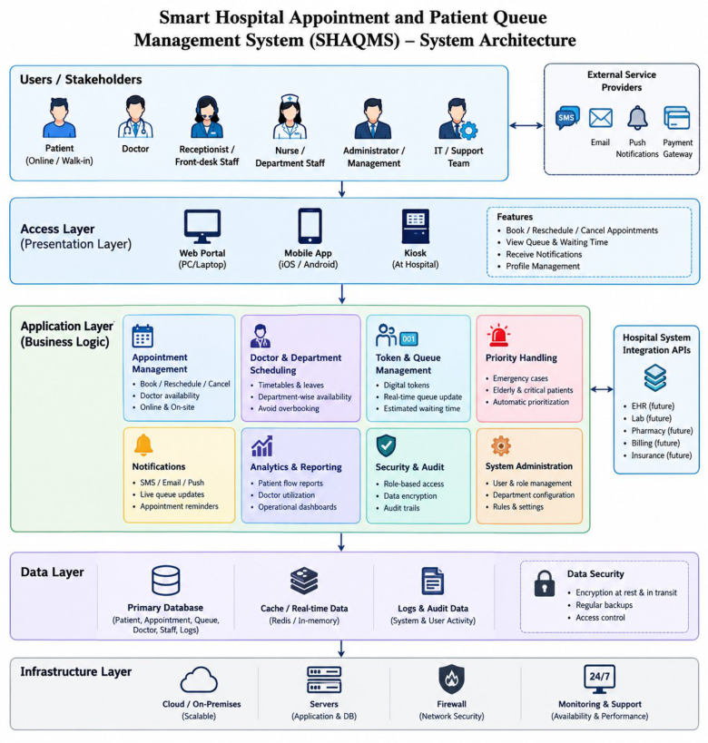
componentto deliverfast, real-timequeueupdates. ExternalSMS, emailand
push gateways are connected through a notification service.
A patientbooks a slot onlineor receivesa tokenon arrival.The queueengine
ranks patients by appointment time, arrivaltime and prioritycategory,
calculates the expectedwaitingtime fromthe averageconsultationduration,
andrecalculatesthe queuewhenevera doctoris late, a patientis absent or a
consultationoverruns.Updatedstatus is pushedto patientsimmediately,and
all events are stored fordashboards and audit reports.
Figure 1: Complete System Architecture
Figure 1: Layered architecture of SHAQMS Surender
4.2 Describe the majorfunctional modules of the proposed system
Module Description
Page 5

User and Access Registration, login, and role-based access control for
Management patients, doctors, receptionists and administrators.
Doctor and Maintains timetables, leaves, room allocation and
Department department-wise availability.
Scheduling
Token and Queue Issues digital tokens for appointments and walk-ins,
Management manages live queues and calls the next patient.
Priority and Smart Prioritizes emergency, elderly and critical cases, handles
Scheduling delays and absentees and predicts no-shows.
Notification Service Sends confirmations, reminders and live waiting-time ale
by SMS, email orapp notification.
Analytics and Dashboards for patient flow, doctor utilization and waitin
Reporting time, with exportable reports.
Audit and Security Logs all critical actions, encrypts data and supports priva
and compliance requirements.
4.3 Identify the functional and non-functional requirements
Functional requirements:
• The system shallallowpatientsto register,log in and book,reschedule
orcancel appointments.
• The system shall maintaindoctor schedules, leaves and department
availability.
• The system shallgeneratea uniquedigitaltokenfor everyappointment
and walk-in patient.
• The system shall updatequeuepositions and estimatedwaitingtimes
in real time.
• The system shallautomaticallyprioritizeemergency,elderlyand critical
patients.
• The system shall send remindersand livequeuenotificationsby SMS,
email ormobile app.
• The system shall adjust the queue whena doctor is late, a patientis
absent ora consultation overruns.
• The system shall provideadministratordashboards,reportsand audit
trails.
Non-functional requirements:
• Performance:queue updates and page responses withinabout two
seconds undernormal load.
Page 6

• Scalability:supportmany concurrentusers and multipledepartments
orbranches.
• Availabilityand reliability:high availability(target 99.5% or more) with
fault tolerance and regularbackups.
• Security and privacy:encryptionin transit and at rest, role-based
access and audit logs.
• Usability:simple, accessible interfaces for patients of all ages, with
multi-language support.
• Maintainability:modularcode, documentationand automatedtests to
alloweasy change.
• Compatibility:works on common browsers and mobile devices and
integrates with hospital systems.
4.4 Explain how software engineering principles are incorporated into your
solution
Principle HowIt Is Incorporated
Modularity The system is divided into independent modules (appointmen
queue, notification, analytics) with well-defined interfaces, so
each can be developed, tested and changed separately.
Scalability Stateless services, load balancing, database indexing and
caching allow horizontal scaling from one clinic to many
branches.
Maintainability Clean layered design, coding standards, version control,
documentation and automated testing make changes and fixe
easier.
Reliability Database backups, failover servers, retry mechanisms for
notifications and graceful handling of errors protect continuo
operation.
Usability Simple booking flow, clear token and waiting-time display,
mobile-friendly screens and accessibility features suit all users.
Security Role-based access control, authentication, encryption, input
validation and audit trails protect sensitive patient data.
5. J ustify the Chosen Methodology/Framework
5.1 Select an appropriate Software Development Life Cycle (SDLC) model or
software development framework
Page 7

The Agile methodologyusing the Scrum framework,supportedby DevOps
practices such as continuousintegrationand continuousdelivery(CI/CD), is
selected for this project. Developmentis organized in two to three week
sprints, each deliveringa working increment, for example appointment
booking first, then queue management, notifications and analytics.
5.2 Justify why the selected methodology/framework is suitable for the
proposed system
• Evolvingrequirements:hospitalworkflows,priorityrulesand reporting

needs will change after feedback from doctors, staff and patients,
which Agile handles well, whereas Waterfall resists change.
• Earlyvalue:a usable bookingand token modulecan be releasedearly
and improved in latersprints.
• Continuous stakeholder involvement:sprint reviews allow doctors,
receptionists and administrators to validate features regularly.
• Risk management:frequent releases expose technical and usability
risks early, which is preferableto the long delay before feedback in
Waterfall.
• Qualityand speed: CI/CD and automatedtesting providefaster, safer
and more reliable releases fora system that must stay available.
5.3 Explain how it supports successful project development and
maintenance
Scrumgives the team a clear structurethrougha prioritizedproductbacklog,
sprint planning,daily stand-ups, reviews and retrospectives,which keeps
progress transparent and continuously improving. Working software is
deliveredregularly,so defects arefoundand fixedearly.Afterdeployment,the
same | cycle | supports | maintenance: new | requests, | bug | fixes | and
enhancementsare added to the backlog and released in short increments.
DevOps automationof builds, testing, deploymentand monitoringreduces
downtime,and thoroughdocumentationand versioncontrolkeep the system
maintainable overtime.

6. Discuss Expected Outcomes and Limitation

Page 8
page 8
6.1 Describe the expected benefits of the proposed solution
ced patient waiting time and less crowding in waiting area Betterdoctorand resource utilization through balanced scheduling.

Fasterhandling of emergency and priority cases.

• Greatertransparency, as patients can see theirturn and expected wait.

• Lowermanual workload forfront-desk staff.

• Data-driven decisions on staffing and scheduling.

• Protected patient data and support forprivacy compliance.

• Abilityto scale from a single clinic to a multi-departmentor multi-
branch hospital.
6.2 Explain howthe solution addresses the identified challenges
Identified Challenge Howthe Solution Addresses It
Long, unpredictable Real-time queue engine and live waiting-time
waiting times estimates keep patients informed and flowbalanced.
Overcrowded waiting Remote tokens and notifications let patients arrive
areas just before theirturn.
Double bookings and no- Slot validation, smart scheduling and automated
shows reminders.
Uneven doctorworkload Centralized schedules and utilization analytics for
balanced allocation.
Delayed emergency Automatic priority rules for emergency, elderly and
handling critical cases.
Lack of data forplanning Dashboards, reports and audit trails for
administrators.
Data security concerns Role-based access, encryption and audit logging.
Page 9

6.3 Discuss potential risks, implementation challenges, and limitations
Risk / Challenge Mitigation
Staff resistance and training Phased rollout, training sessions and simple
needs interfaces.
Data privacy and security Encryption, access control, regular security testin
breaches and audits.
System downtime or Redundant servers, backups and an offline
network failure fallback token process.
Notification delivery failure Multiple channels (SMS, email, app) and retry
mechanisms.
Inaccurate waiting-time Continuous tuning using historical consultation
estimates data.
Integration with existing Standard APIs and early integration testing.
hospital systems
Limitations:the system depends on reliable internet and power; some
patients,especiallyelderlyor ruralusers, mayhavelimiteddigitalaccess and
stillneed front-deskassistance; the initialcost of development,hardwareand
trainingcan be high;and waiting-timepredictionsremainestimates that are
affected by unpredictable medical situations.
6.4 Suggest possible future enhancements

• AI-based prediction of waiting time, demand and no-shows.

• Telemedicine and video consultation integration.

• Integrationwith electronic health records, laboratoryand pharmacy
systems.
• Voice assistant and chatbot forbooking and queries.

• Online payments and insurance verification
.
• QR-code check-in and indoornavigation within the hospital.

• Multilingual support and wearable orIoT-based patient monitoring.
Page 10

